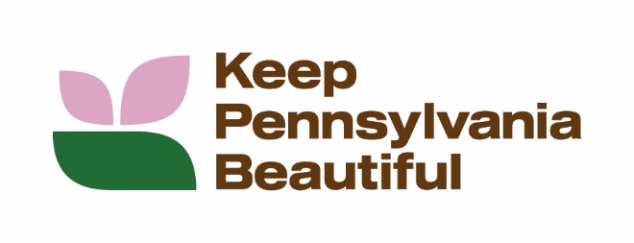



FOR IMMEDIATE RELEASE
Contacts:
Ashley Flower Stephanie Larson
860-966-1727 724-836-4121
ashley.flower@giantmartins.com slarson@keeppabeautiful.org

THE GIANT COMPANY AND KEEP PENNSYLVANIA BEAUTIFUL AWARD 21 COMMUNITY GRANTS FOR NATIVE PLANTINGS

CARLISLE, Pa., June 25, 2026 – The GIANT Company, known locally as GIANT and MARTIN’S, in partnership with Keep Pennsylvania Beautiful, today announced the 21 recipients of its 2026 Healing the Planet grant program. A total of $100,000 was given to support projects across the company’s operating areas in Pennsylvania.

“Real change happens when businesses and community partners come together to make a difference,” said Courtney Hopcraft, manager of community relations and strategic partnerships, The GIANT Company. “At The GIANT Company, we’re committed to making a positive impact where we live and work. Our Healing the Planet grant program, offered with the support of Keep Pennsylvania Beautiful, is one of the ways we’re helping to create healthier, greener spaces in the neighborhoods we serve.

The following Pennsylvania organizations are the recipients of a 2026 Healing the Planet grant from GIANT and Keep Pennsylvania Beautiful:

- 18th Wonder Improvement Association, Reading
- America 250 PA Lehigh County, Bethlehem
- Borough of Aldan, Aldan
- City of Easton, Easton
- ClearWater Conservancy of Central Pennsylvania, State College
- Community Action Commission dba Tri County Community Action, Harrisburg
- Cumberland County, Carlisle
- Friends of Peace Valley Nature Center, Doylestown
- George Washington High School, Philadelphia
- Goshen Township, Clearfield
- Indiana Borough, Indiana
- Lititz Public Library, Lititz
- Loyalsock Foundation, Laporte
- North Branch Land Trust, Dallas
- Pennsylvania Environmental Council, Pittston
- Society of St Vincent De Paul Uniontown Conference, Uniontown
- Stroud Water Research Center, Inc., Avondale
- Township of Abington, Abington
- Township of Concord, Glen Mills
- Wild Ones Natural Landscapers, Ltd., Neenah
- York County Industrial Development Authority, York

Since 2021, GIANT has partnered with Keep Pennsylvania Beautiful to offer over $1.4 million in Healing the Planet grants to recipients, empowering projects that connect communities with green spaces, protect and improve local waterways and water resources, prevent, reduce, and recover food waste, and support native plantings and habitat restoration.

“Community plantings foster shared responsibility and stewardship, strengthening social ties. Native plants provide food and shelter for local wildlife, improve water conservation, provide protection from soil erosion and can survive with minimal care. Beautifying communities also tends to reduce littering and other illegal behaviors, making it a better place for all residents and providing a foundation for community and economic development,” said Heidi Pedicone, director of programs, Keep Pennsylvania Beautiful. “We are proud to support Pennsylvania organizations in planting native species across their communities and are honored to continue our partnership with GIANT.”

Keep Pennsylvania Beautiful has supported community improvement initiatives and encouraged community leadership, responsibility, and respect for the environment since 1990. Keep Pennsylvania Beautiful, a state affiliate of Keep American Beautiful, Inc. has more than 35 years of experience in organizing volunteer-driven community improvement events. Visit keeppabeautiful.org for more information on programs or to find an event near you.

###

About The GIANT Company
For over 100 years, The GIANT Company has been bringing fresh food at great prices to local neighborhoods across Pennsylvania, Maryland, Virginia, and West Virginia. Known locally as GIANT and MARTIN'S, the company’s more than 35,000 team members are dedicated to delivering value, freshness and kindness, every day. Founded and based in 1923 in Carlisle, Pa., the company has nearly 200 stores, online grocery services, pharmacies, and fuel stations to meet the ever-evolving needs of today’s customers and communities. The GIANT Company is a company of Ahold Delhaize USA. For more information, visit the GIANT or MARTIN’S websites.
About Keep Pennsylvania Beautiful
Keep Pennsylvania Beautiful’s vision is a clean and beautiful Pennsylvania. Since 1990, Keep Pennsylvania Beautiful has supported hundreds of thousands of volunteers across the state in their community improvement efforts. Keep Pennsylvania Beautiful’s core programming focuses on litter and illegal dump prevention, cleanup, community greening, and proper waste handling and sustainable practices. Keep Pennsylvania Beautiful works with many partnering organizations on the state and grassroots level to accomplish our goal of a clean and beautiful Pennsylvania. Keep Pennsylvania Beautiful is the state affiliate of Keep America Beautiful, Inc., the nation’s largest volunteer-based community action and education organization. To learn more about Keep Pennsylvania Beautiful, visit www.keeppabeautiful.org.

