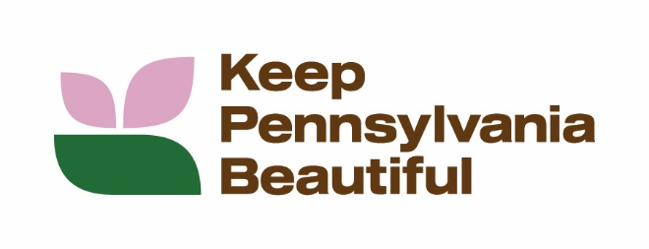

KEEP PENNSYLVANIA BEAUTIFUL - PICK UP PENNSYLVANIA
The state’s largest community improvement initiative
Sample Social Media Posts

FACEBOOK
Promote your local event:
- We're excited to announce our participation in Keep Pennsylvania Beautiful's PICK UP PA, Pennsylvania’s largest community improvement initiative! Let's come together to make a difference in our community.
Date: [Insert Date]
Location: [Insert Area Name]
Every piece of trash we collect will contribute to our state and national cleanup efforts. Let's show our pride and make our neighborhood shine! See you there!
- (Name or Organization) is hosting a Keep Pennsylvania Beautiful PICK UP PENNSYLVANIA event by planting trees and flower bulbs at (local park/area of event). You’re invited to help us keep our neighborhood clean and beautiful! To participate, contact (insert event date and directions on how to register with your group).
- I am passionate about (INSERT PASSION). That’s why I’m planning a Pick Up Pennsylvania cleanup at (LOCATION) on (DATE/TIME) to (REASON YOU’RE CLEANING IT UP). Would you help me by joining my efforts? Learn more and RSVP at (contact information).
- We are gearing up for our annual cleanup of (name of area/road/park). Keep Pennsylvania Beautiful is providing cleanup supplies through their PICK UP PENNSYLVANIA initiative, the state’s largest community improvement initiative. There will be a friendly competition to see who can find the most unusual item. Join us on (date) by contacting (contact information).
- Meet neighbors and help keep your community clean and beautiful. We are planning a cleanup of (area/road/park) on (date). Keep Pennsylvania Beautiful is providing cleanup supplies through their PICK UP PENNSYLVANIA, the state’s largest community improvement initiative. Register here (registration info or link to contact).
INSTAGRAM
Promote your local event:
- Join Us to Keep Pennsylvania Beautiful!
We’re hosting a PICK UP PENNSYLVANIA event at (local park/area) by planting trees and flower bulbs to make our neighborhood shine!
📅 Event Date: (insert date)
📍 Location: (local park/area)
✅ Want to help? Register with your group today! (insert registration details)
Let’s work together to keep our community clean, green, and beautiful!
- Join Us to Keep Pennsylvania Beautiful!
We’re hosting a PICK UP PENNSYLVANIA event at (local park/area) by cleaning up litter to make our neighborhood shine!
📅 Event Date: (insert date)
📍 Location: (local park/area)
✅ Want to help? Register with your group today! (insert registration details) Let’s work together to keep our community clean, green, and beautiful!
- #DidYouKnow that over 500 million pieces of trash litter Pennsylvania’s roadways? I’m organizing a group of friends to cleanup (LOCATION) at (TIME) on (DATE). RSVP to attend here: (event info) or via my link in bio.
- You’re cordially invited to attend our (Name of Area) Cleanup! Fulfill your high school or college community service hour requirements, meet new people, get outdoors and give back to the community! Join us on (DATE) at (LOCATION) from (TIMES). RSVP at (Event Info).

Promote Keep Pennsylvania Beautiful’s PICK UP PENNSYLVANIA initiative:
- Register an event with Pick Up Pennsylvania and be a part of the state’s largest community improvement initiative! Registered events can get free trash bags, gloves, and safety vests sponsored by the PA Department of Environmental Protection and PennDOT from March through May, as supplies last. For more information visit, https://www.keeppabeautiful.org/programs/pick-up-pa/.

- Looking for a fun, impactful way to connect with your community this spring? Join Pick Up Pennsylvania, the state's largest volunteer cleanup effort! From March 1–May 31, register your event to get free gloves, safety vests, trash bags, and even free/reduced landfill disposal (April 1–30), while supplies last. Visit www.keeppabeautiful.org.

- According to the Pennsylvania Litter Research Study sponsored by the Department of Environmental Protection, PennDOT and Keep Pennsylvania Beautiful, the presence of litter in an area will likely attract more litter. Join PICK UP PENNSYLVANIA, the state’s largest community improvement initiative, from March 1 through May 31 and receive free trash bags, safety vests and gloves, as supplies last. Visit www.keeppabeautiful.org.

- As part of PICK UP PENNSYLVANIA, the state’s largest community improvement initiative, the PA Department of Environmental Protection and Pennsylvania Waste Industries Association are sponsoring trash disposal, free or at a reduced cost, for registered programs at participating landfills from April 1 through April 30, with prior approval. Register your event here: www.keeppabeautiful.org.

- Over 3.4 million pounds of trash and recyclables were picked up by 53,635 volunteers from March through May last year during Keep Pennsylvania Beautiful’s PICK UP PENNSYLVANIA, the state’s largest community improvement initiative. If everyone picked up one bag of litter this spring, the results would be powerful. Visit www.keeppabeautiful.org.

SUGGESTED HASHTAGS:
#PUPA
#PickUpPennsylvania
#PickUpPA
#PAFightsDirty
#EveryLitterBitMatters
#keepPAbeautiful
#KeepPennsylvaniaBeautiful
Tag our page on Facebook, Instagram, and or LinkedIn posts: Facebook and LinkedIn: @ Keep Pennsylvania Beautiful Instagram: @keeppabeautiful

