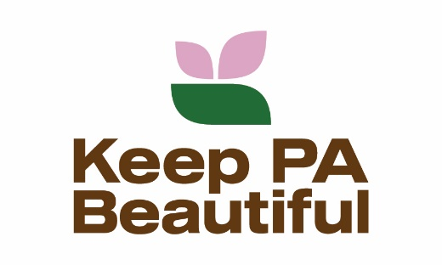
KEEP PENNSYLVANIA BEAUTIFUL - PICK UP PENNSYLVANIA
supporting the International Coastal Cleanup
Sample Social Media Posts

Promote your local event:
- Because most marine debris originates on land, we’re holding a neighborhood cleanup as part of Keep Pennsylvania Beautiful’s PICK UP PENNSYLVANIA – supporting the International Coastal Cleanup. Join us at (name of area) on (date). All trash collected counts towards state and national cleanup numbers.
- We will be helping to keep our waterways clean by picking up trash before it reaches our oceans at our annual cleanup of (name of waterway/area/road/park). Keep Pennsylvania Beautiful is providing cleanup supplies through PICK UP PENNSYLVANIA – supporting the International Coastal Cleanup. There will be a friendly competition to see who can find the most unusual item. Join us on (date) by contacting (contact information).
- Meet neighbors and help keep our community and waterways clean and beautiful. We are planning a cleanup of (waterway/area/road/park) on (date). Keep Pennsylvania Beautiful is providing cleanup supplies through PICK UP PENNSYLVANIA – supporting the International Coastal Cleanup. Register here (registration info or link to contact).
- We need a cleanup crew to on (date) to help clean up litter along (waterway/area/road/park). Keep Pennsylvania Beautiful is providing cleanup supplies through PICK UP PENNSYLVANIA – supporting the International Coastal Cleanup. Contact (contact info).
Promote Pick Up Pennsylvania:
- Registration is open! Join Pick Up Pennsylvania – supporting the International Coastal Cleanup to keep litter from reaching our waterways.www.keeppabeautiful.org

- We’re picking up litter before it makes it way to our oceans! Join Keep Pennsylvania Beautiful’s PICK UP PENNSYLVANIA – supporting the International Coastal Cleanup now to make a difference in your community. www.keeppabeautiful.org

- There are over 500 million pieces of trash on our roadways. Let’s pick it up before it reaches our waterways. Join PICK UP PENNSYLVANIA – supporting the International Coastal Cleanup. www.keeppabeautiful.org

- FREE SUPPLIES! Register with KPB’s PICK UP PENNSYLVANIA – supporting International Coastal Cleanup today. www.keeppabeautiful.org

Tag us, PennDOT and DEP on Facebook, twitter, Instagram and LinkedIn:
@keeppabeautiful
@pennsylvaniadepartmentoftransportation
@pennsylvaniadepartmentofenvironmentalprotection

