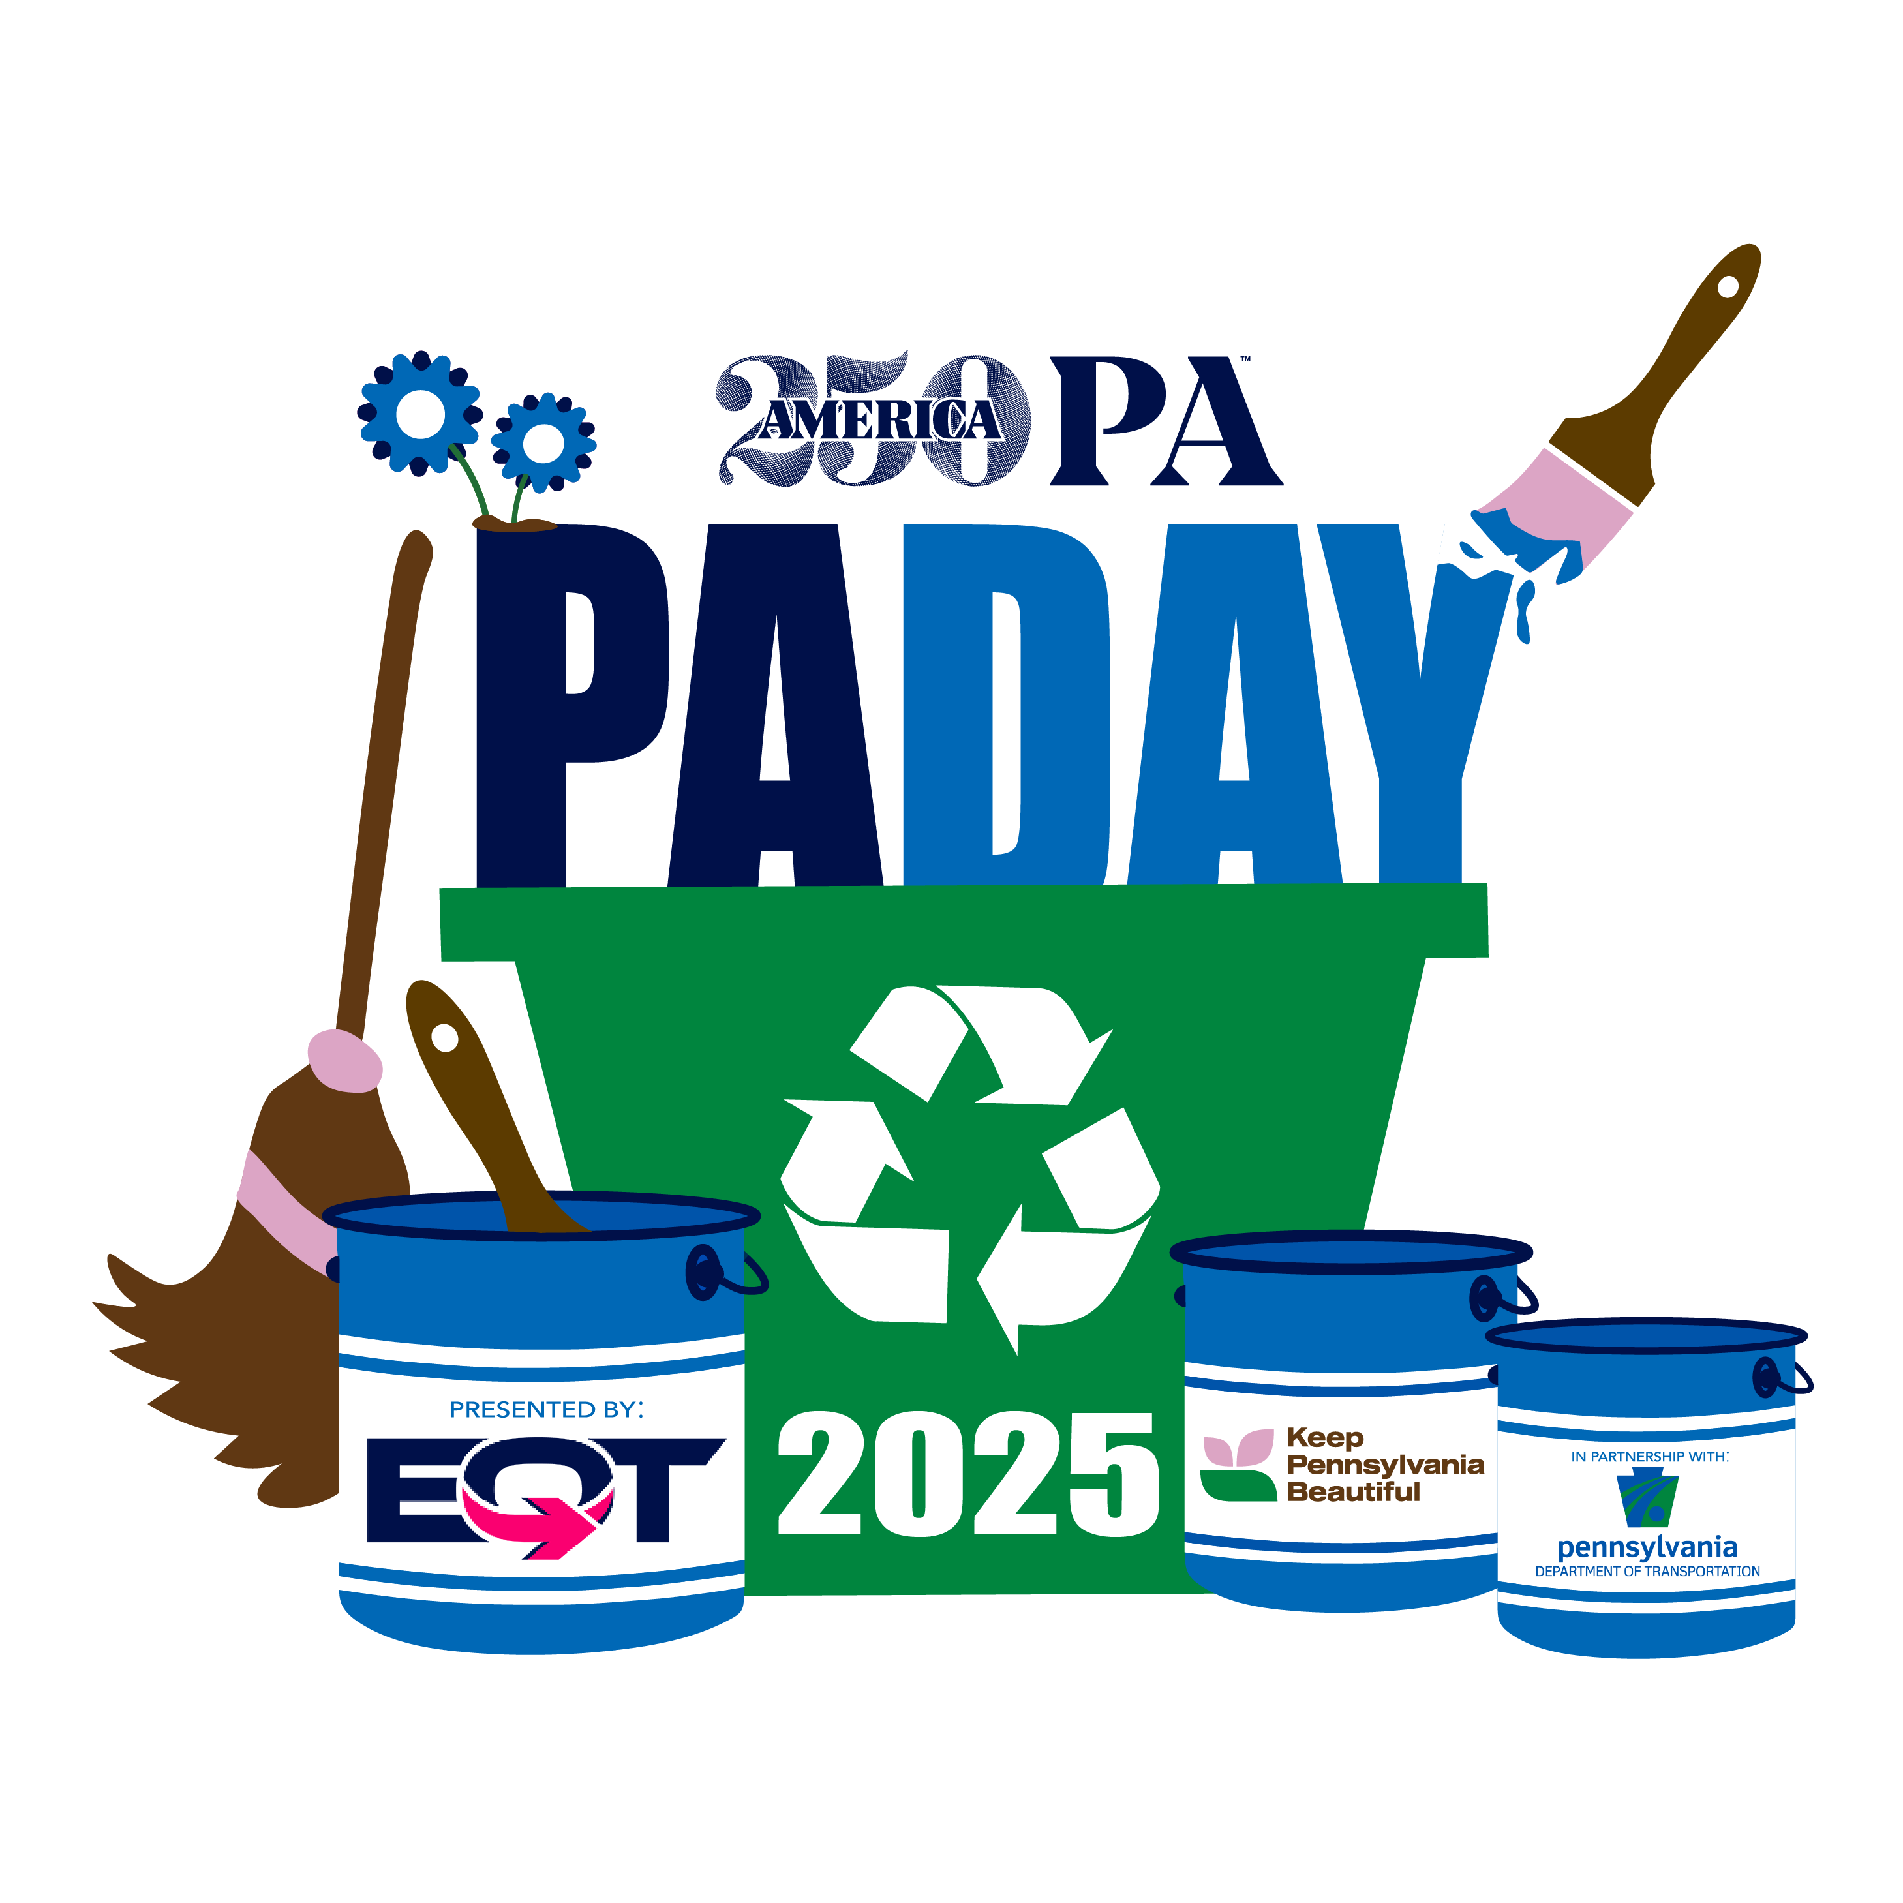
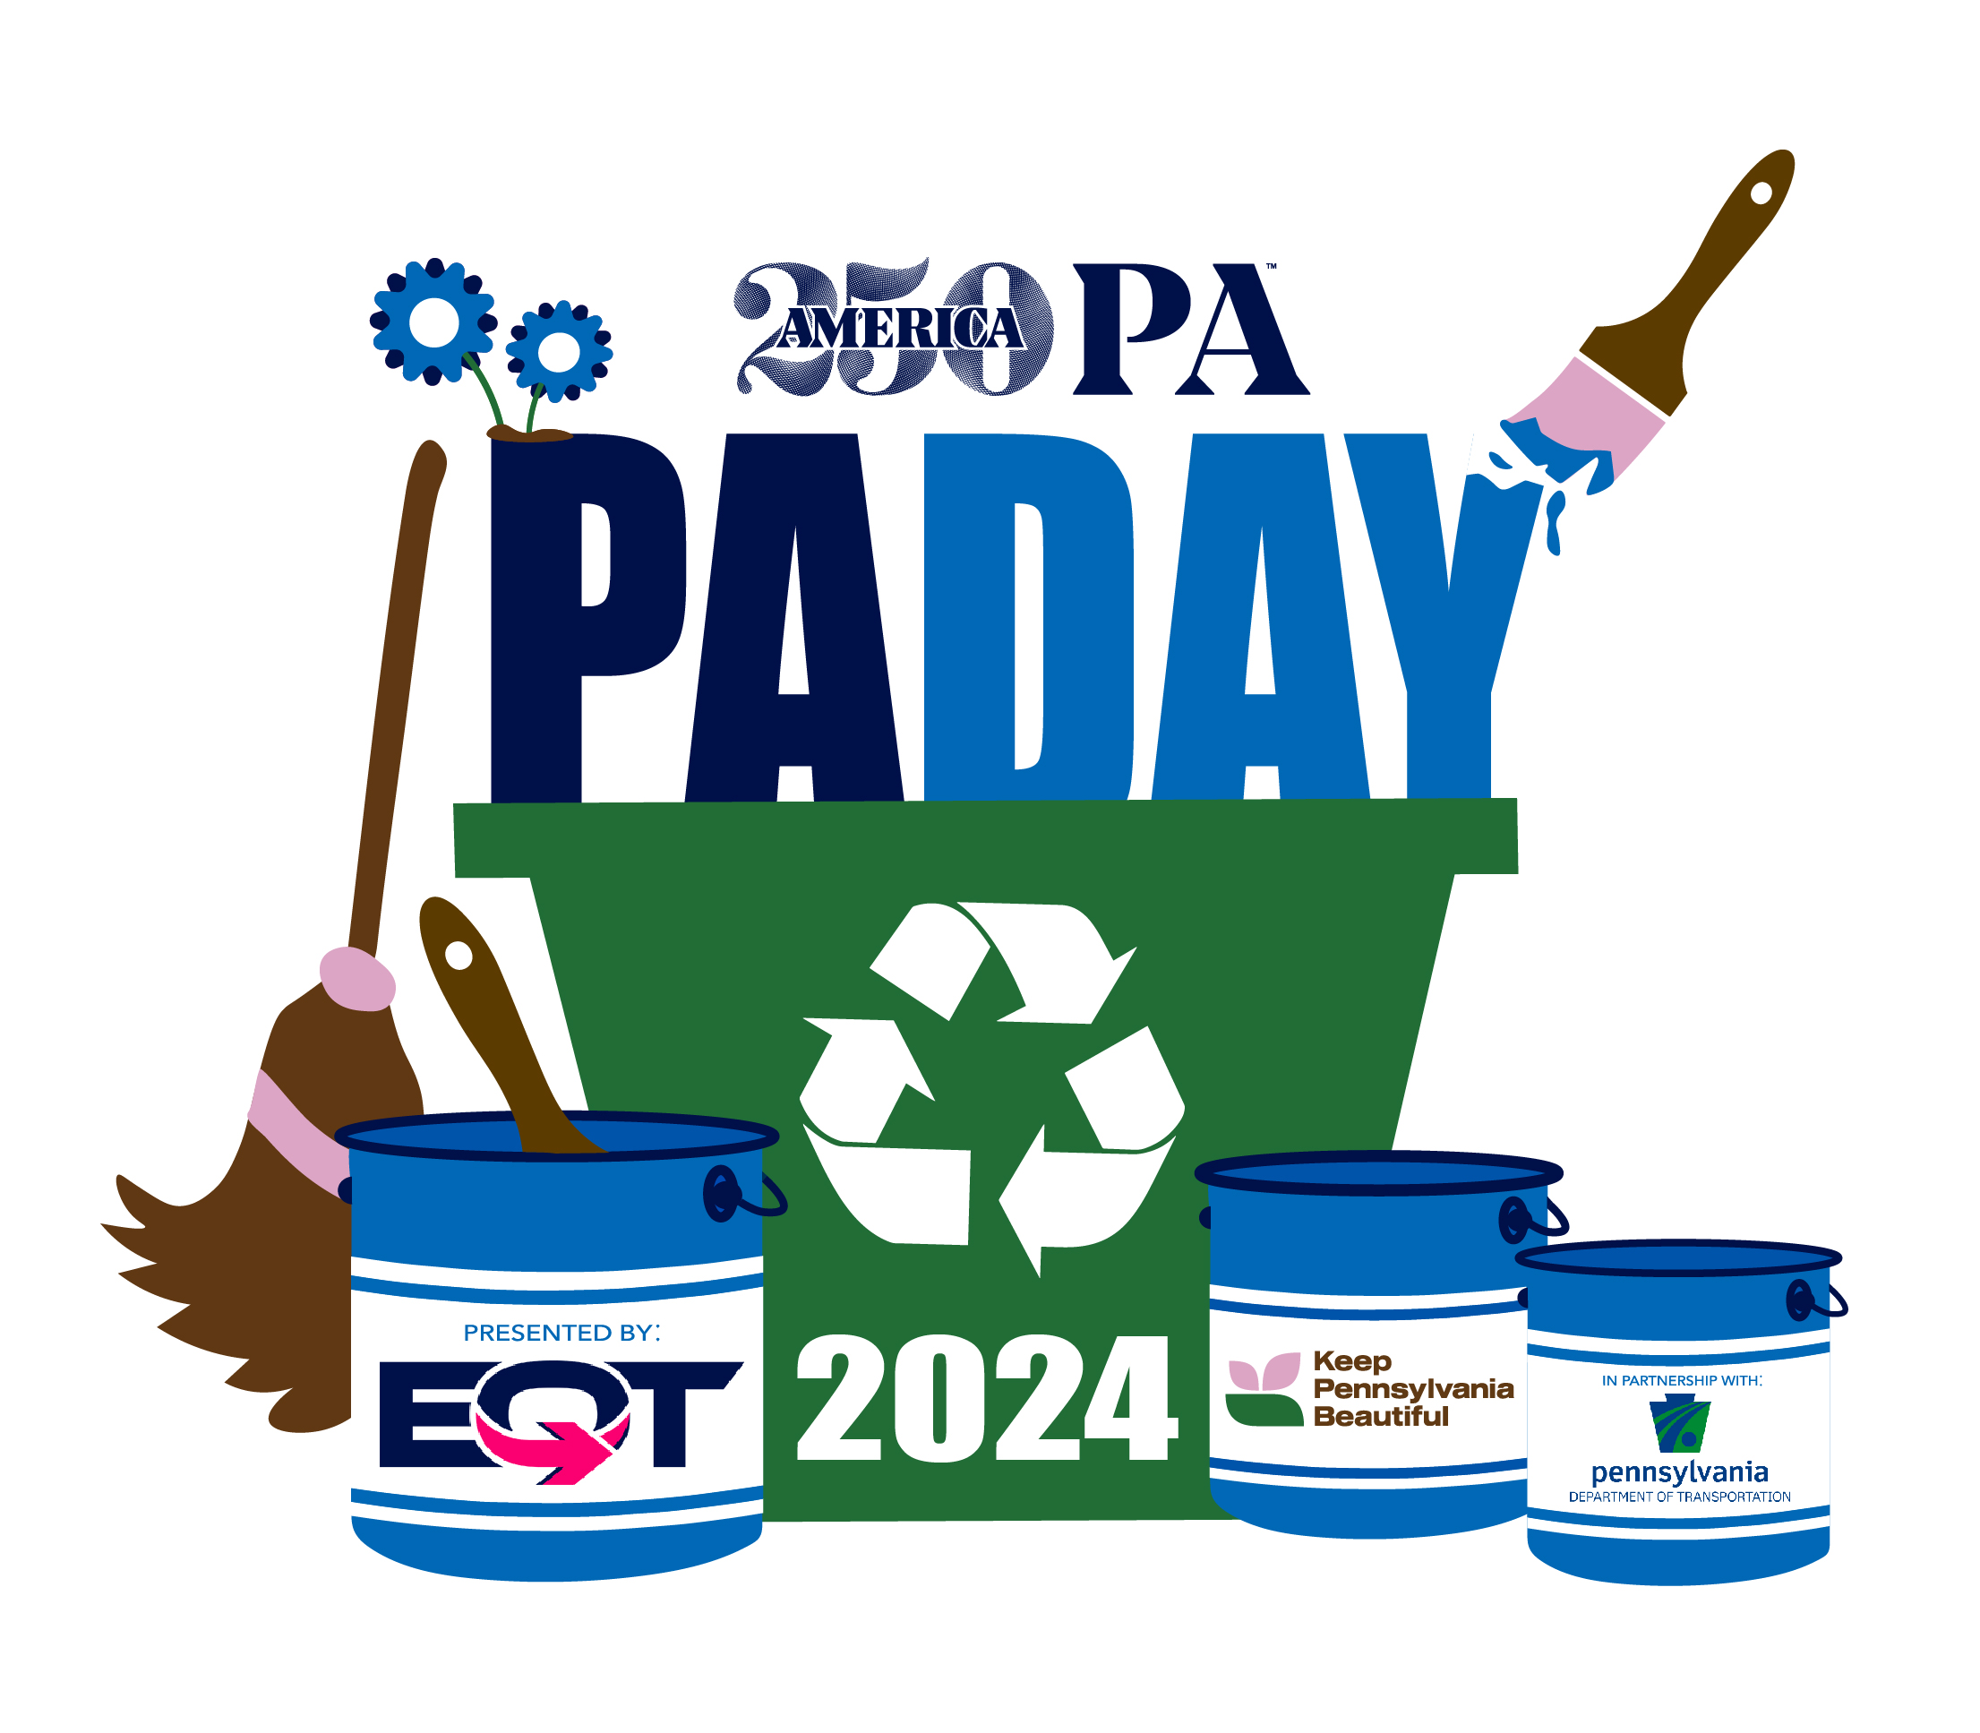
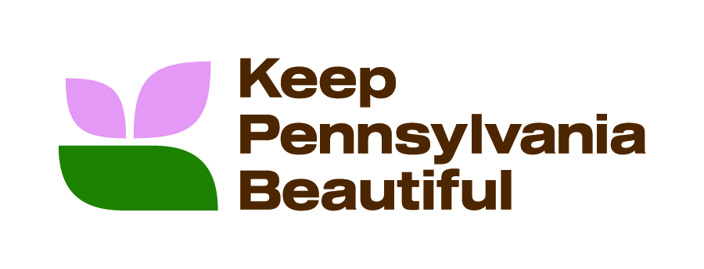

2025 National Pennsylvania Day Mini Grants

If your organization is active on social media, please consider sharing the good news about your 2025 National Pennsylvania Day Mini Grants with your followers! Included below are a few sample posts you are welcome to use as well as the proper handles to use depending on which platform you are posting on:

- [ORGANIZATION NAME] is excited to receive a $#### National Pennsylvania Day Mini Grant from America250PA and EQT, in partnership with the PA Dept. of Transportation, in support of the Keep Pennsylvania Beautiful project [PROJECT TITLE]. Register to volunteer now: https://bit.ly/PADay24.

- Thank you, America250PA and EQT, in partnership with PA Dept. of Transportation, for supporting the Keep Pennsylvania Beautiful project [PROJECT TITLE] with your National Pennsylvania Day Mini Grant. We received $#### to [INSERT WHAT $ WILL BE USED FOR]. Register to volunteer now: https://bit.ly/PADay24.

- Through the generosity of America250PA and EQT, in partnership with PA Dept. of Transportation, we are the lucky recipient of a $### grant to help [INSERT WHAT $ WILL BE USED FOR] to support Keep Pennsylvania Beautiful. Thank you all for supporting community improvement projects like ours! (or) Thank you America250PA, Keep Pennsylvania Beautiful, EQT and PennDOT for supporting community improvement projects like ours! Register to volunteer now: https://bit.ly/PADay24.

- In support of Keep Pennsylvania Beautiful projects that address community and public space improvements, America250PA and EQT, in partnership with PA Dept of Transportation, awarded over $30,000 in funding to 10 grant recipients, including $#### to [ORGANIZATION NAME]. Register to volunteer now: https://bit.ly/PADay24.

Also, when posting to your respective social media channel, please tag America250PA, EQT, PennDOT and Keep Pennsylvania Beautiful so that we may also share these great projects. The following are the correct handles for each company:

FACEBOOK
- America250PA: @America250PA
- Keep Pennsylvania Beautiful: @Keep Pennsylvania Beautiful
- PennDOT: @PennsylvaniaDepartmentofTransportation
- EQT: @EQTCorporation

TWITTER
- America250PA: @America250_PA
- PennDOT: @PennDOTNews
- EQT: @EQTCorp

LINKEDIN
- America250PA: @America250PA
- Keep Pennsylvania Beautiful: @Keep Pennsylvania Beautiful
- PennDOT: @Pennsylvania Department of Transportation (PennDOT)
- EQT: @EQT Corporation

INSTAGRAM
- America250PA: @america250_pa
- Keep Pennsylvania Beautiful: @keeppabeautiful
- PennDOT: @Pennsylvaniadot
- EQT: --

Approved Hashtags:
#PAProud, #America250PA, #EPIC, #KeystoneKindness, #EveryCounty#EveryPennsylvanian, #JOINUS, #ImpactfulPartnerships, #Impact250PA

