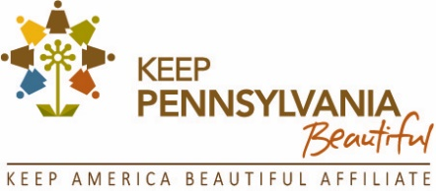
FOR IMMEDIATE RELEASE
January 19, 2023
Stephanie Larson, Program Coordinator
Keep Pennsylvania Beautiful
Tel: (724) 836-4121 x104
Email: slarson@keeppabeautiful.org
Web site: www.keeppabeautiful.org

Keep Pennsylvania Beautiful Wants You to Fight Dirty! Register now for the Pick Up Pennsylvania Community Improvement Program
Cleanup training webinar offered – March 1
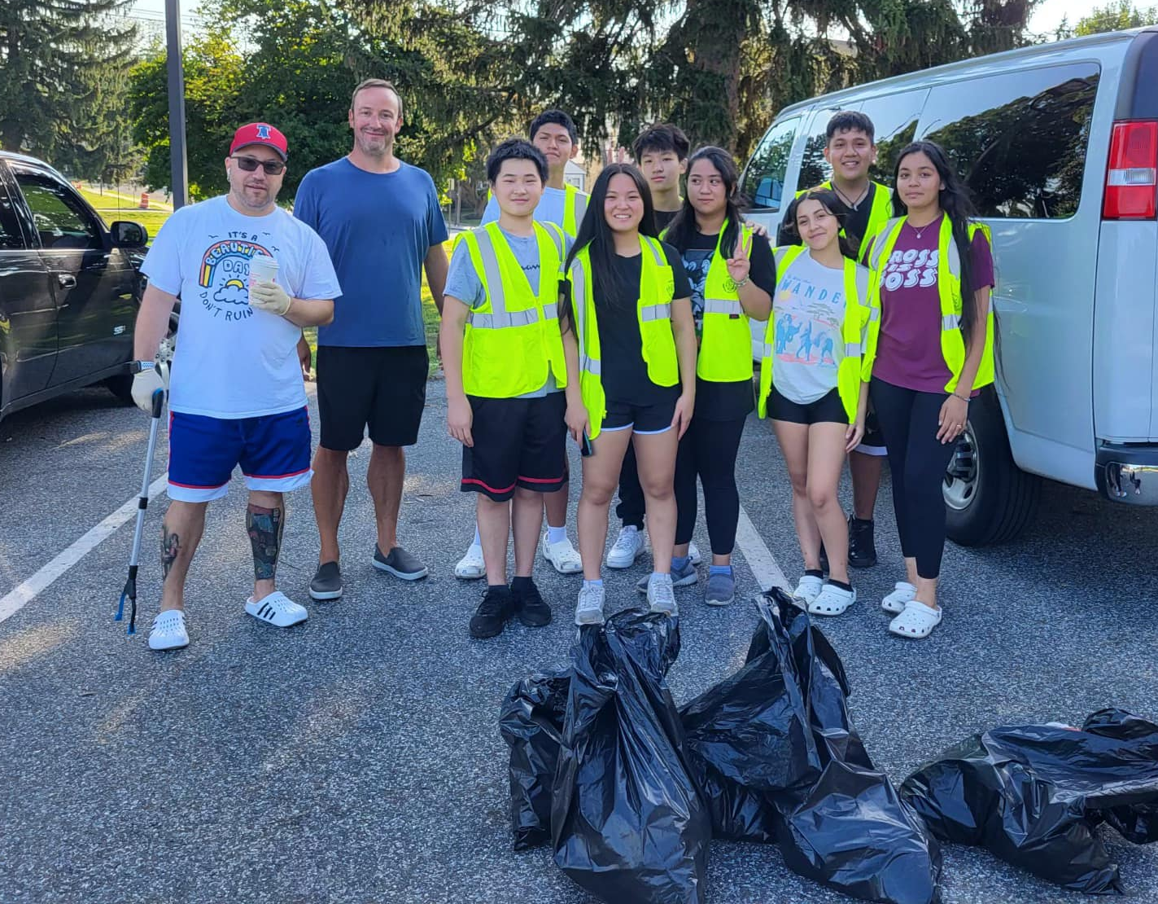

Are you ready to Fight Dirty? Keep Pennsylvania Beautiful has announced that registration is open for the 2023 Pick Up Pennsylvania, a community improvement initiative. Pick Up Pennsylvania is a year-long initiative, however, events scheduled from March 1 through May 31 receive free trash bags, gloves, and safety vests provided by support from the Pennsylvania Department of Environmental Protection, PennDOT and Keep America Beautiful, as supplies last. Events can include litter cleanups, illegal dump cleanups, community greening and beautification, special collections and education events. Events must be registered at keeppabeautiful.org to receive free cleanup supplies.

As part of this event, the Pennsylvania Department of Environmental Protection and Pennsylvania Waste Industries Association are sponsoring trash disposal, free of charge or at a reduced rate for registered program participants, at participating landfills from April 1 through April 30, with prior approval.

Want to fight dirty in your community but not sure where to start? Keep Pennsylvania Beautiful is hosting a community cleanup training webinar on March 1 from 7-8 pm. The training will include technical support for choosing an event location, organizing and mobilizing volunteers, coordinating trash disposal, accessing supplies and resources and more! A link will be made available closer to the date of the webinar at keeppabeautfiul.org, choose Programs, then Pick Up PA.

“Most people don’t think small pieces of litter make an impact, but it really does add up. Every Litter Bit Matters when it comes to keeping Pennsylvania beautiful. By working together to pick up a little litter, we can make big improvements in our quality of life. We’re hoping that after the long winter, our residents are ready to get out there and fight dirty in their neighborhoods,” said Shannon Reiter, President of Keep Pennsylvania Beautiful. “Making an area more attractive with plants flowers or a fresh coat of paint can also help keep an area litter free. Anyone can participate in Pick Up PA by going to our website.”

Individuals, friends, family and groups large and small can help clean up vacant lots, streets and riverbanks, plant gardens and trees or mulch a local playground. To host an event, join an event near you or to inquire about free supplies and trash disposal, visit keeppabeautiful.org, choose Programs, then Pick Up PA or contact Michelle Dunn, Pick Up Pennsylvania Program Coordinator, at 877-772-3673 ext. 113 or mdunn@keeppabeautiful.org.

Last year from March through May, 56,967 people participated in Pick Up Pennsylvania. Over 3.7 million pounds of trash and recyclables were picked up and 101,298 trees, flowers and other greens were planted.

Current 2023 Pick Up Pennsylvania supporters include: The GIANT Company, Wawa, Pennsylvania Waste Indistries Association, Columbia Gas - NiSource Charitable Foundation, Mahantango Enterprises, Inc., PA Food Merchants Association, Professional Recyclers of Pennsylvania, Giant Eagle and Vistra Energy - Luminant. If you are interested in becoming a supporter contact Deb Woolley at dwoolley@keepppabeautiful.org.

###

About Keep Pennsylvania Beautiful
Keep Pennsylvania Beautiful’s vision is a clean and beautiful Pennsylvania. Since 1990, Keep Pennsylvania Beautiful has worked with hundreds of thousands of volunteers across the state to pick up nearly 152 million pounds of trash from Pennsylvania's roadways, waterways, greenways, vacant lots, forestlands and other community spaces. Keep Pennsylvania Beautiful’s core programming focuses on litter and illegal dump prevention, cleanup, community greening, and proper waste handling and sustainable practices. Keep Pennsylvania Beautiful works with many partnering organizations on the state and grassroots level to accomplish our goal of a clean and beautiful Pennsylvania. Keep Pennsylvania Beautiful is the state affiliate of Keep America Beautiful, Inc., the nation’s largest volunteer-based community action and education organization. To learn more about Keep Pennsylvania Beautiful, visit www.keeppabeautiful.org.

