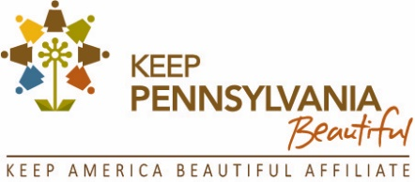
FOR IMMEDIATE RELEASE
Michelle Dunn, Program Coordinator
Keep Pennsylvania Beautiful
Tel: (724) 836-4121 x113
Email: mdunn@keeppabeautiful.org
Web site: www.keeppabeautiful.org

Trash Travels – Join Keep Pennsylvania Beautiful for the 2021 Pick Up Pennsylvania Program to Keep Our Waterways Clean
~ September 1 through November 30 ~
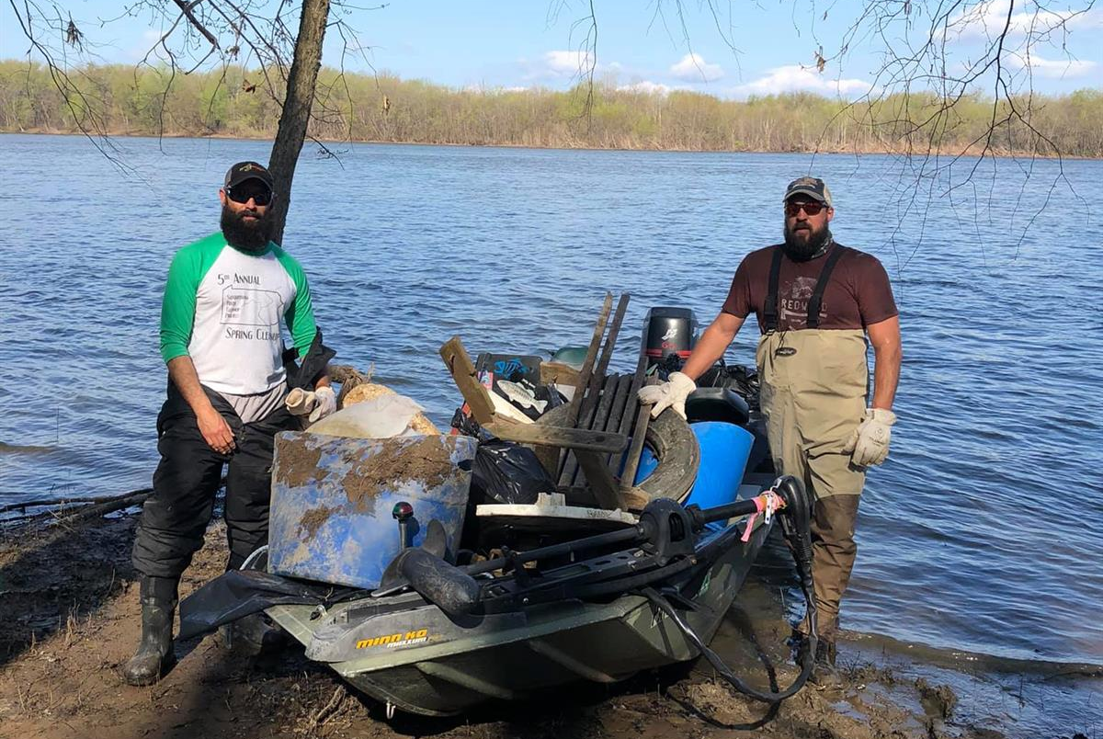

(August 4, 2021) To prevent litter from ending up in our waterways, Keep Pennsylvania Beautiful urges Pennsylvania residents to participate in Pick Up Pennsylvania, in support of the Ocean Conservancy’s International Coastal Cleanup. This annual event is an opportunity to improve neighborhoods and Pennsylvania’s waterways by coordinating or participating in a litter cleanup. Registration is now open.

This year’s program runs from September 1 through November 30. During this period, registered events can get free trash bags, gloves, and safety vests provided by the Pennsylvania Department of Environmental Protection, PennDOT and the Ocean Conservancy, as supplies last.

In addition to waterway cleanups, land-based cleanups are also eligible since a significant portion of waterway pollution originates on land. The results of a 2019 statewide study on litter, conducted by the Departments of Environmental Protection and Transportation and Keep Pennsylvania Beautiful, estimated that there are 502 million pieces of litter on Pennsylvania roadways. That litter could potentially end up in our oceans. Wind and rain wash litter into storm drains or directly into creeks and rivers that eventually flow to the ocean where it impacts marine life, human health and coastal economies.

“Whether you are cleaning up a local waterway, your local park or the street that you live on – it all makes a difference in reducing the amount of litter reaching our oceans. We are honored to provide the resources and supplies needed to help volunteers improve our communities,” explained Shannon Reiter, President of Keep Pennsylvania Beautiful. “Picking up litter is something we can all do to support our communities. Please lend a hand and join us in a cleanup this fall.”

The Ocean Conservancy’s annual International Coastal Cleanup engages hundreds of thousands of volunteers from around the world to remove millions of pounds of plastics and debris from beaches, lakes and waterways. This event has grown to include participation by all 50 states and U.S. territories and 90 countries with the number growing each year. Keep Pennsylvania Beautiful is proud to coordinate this effort in Pennsylvania. In 2020, nearly 12,000 volunteers canvassed their communities to remove 777,650 pounds of trash and 122,600 pounds of tires from Pennsylvania’s lands, waterways and coastal regions from September through November.

Individuals, families, neighbors, students, civic organizations and local governments are all invited to participate. Keep Pennsylvania Beautiful suggests following all applicable federal, state and local health and safety rules for Novel Coronavirus (Covid 19) in effect at the time of the event.

To register your cleanup event, visit keeppabeautiful.org/programs/pick-up-pa/. Questions can be answered by Michelle Dunn, Pick Up Pennsylvania Program Coordinator, at 877-772-3673 ext. 113 or mdunn@keeppabeautiful.org.

Current 2021 Pick Up Pennsylvania supporters include: Columbia Gas of Pennsylvania funded by the NiSource Charitable Foundation, The Giant Company, Coca-Cola, Pennsylvania Waste Industries Association, Wawa, Giant Eagle, Luminent - Fayette Energy Facility, Mahantango Enterprises, Inc., Pennsylvania Food Merchants Association, Republic Services and Wegmans.

If you are interested in making an investment in a cleaner Pennsylvania by becoming a supporter of the 2022 Pick Up Pennsylvania program, contact Shannon Reiter at 724-836-4121 or sreiter@keeppabeautiful.org.

###

About Keep Pennsylvania Beautiful
Keep Pennsylvania Beautiful’s vision is a clean and beautiful Pennsylvania. Since 1990, Keep Pennsylvania Beautiful has worked with hundreds of thousands of volunteers across the state to pick up nearly 148 million pounds of trash from Pennsylvania's roadways, waterways, greenways, vacant lots, forestlands and other community spaces. Keep Pennsylvania Beautiful’s core programming focuses on litter and illegal dump prevention, cleanup, community greening, and proper waste handling and sustainable practices. Keep Pennsylvania Beautiful works with many partnering organizations on the state and grassroots level to accomplish our goal of a clean and beautiful Pennsylvania. Keep Pennsylvania Beautiful is the state affiliate of Keep America Beautiful, Inc., the nation’s largest volunteer-based community action and education organization. To learn more about Keep Pennsylvania Beautiful, visit www.keeppabeautiful.org.

